A881-PAC-Poly-Hi-Hi-Kohala-*kiʻi*–Vesicular lava-c 1200 CE

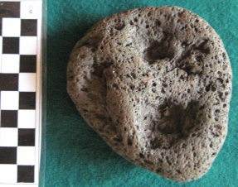 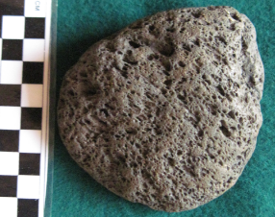 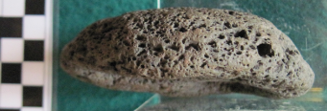

Figs. 1-3. PAC-Poly-Hi-Hi-Kohala-*kiʻi*–vesicular lava-c 1200 CE

**Case no.: 22**

**Accession Number: A881**

**Formal Label:** PAC-Poly-Hi-Hi-Kohala-*kiʻi*–vesicular lava-c 1200 CE

**Display Description:**

The first man in Hawai’ian mythology was Kumuhonua, who was made by [Kāne](https://en.wikipedia.org/wiki/K%C4%81ne" \o "Kāne), [Kū](https://en.wikipedia.org/wiki/K%C5%AB), and [Lono](https://en.wikipedia.org/wiki/Lono" \o "Lono). His body was made by mixing red earth with saliva. He was made in the shape of Kāne, who carried the earth from which the man was made from the four corners of the world. [Kanaloa](https://en.wikipedia.org/wiki/Kanaloa" \o "Kanaloa) was watching when Kāne made the first man, and he too made a man, but could not bring him to life. Kanaloa then said to Kāne, “I will take your man, and he will die.” And so death came upon mankind (Tregear 1891:151).

**LC Classification:**

**Date or Time Horizon:**

**Geographical Area:**

**Map:**

**GPS coordinates:**

**Cultural Affiliation:**

**Medium:** vesicular lava

**Dimensions:**

**Weight:**

**Condition: original**

**Provenance:** Kohala 1966

**Discussion:**

**References:**

Tregear, E. R. 1891. *Maori-Polynesian Comparative Dictionary* (Wellington, Lambton Quay: Lyon and Blair,